**MADRAS INSTITUTE OF TECHNOLOGY ANNA UNIVERSITY**

**DEPARTMENT OF INFORMATION TECHNOLOGY AD23303- DATABASE MANAGEMENT SYSTEMS**

**PROJECT REPORT**

**PROJECT TITLE:MOVIE DATABASE MANAGEMENT SYSTEM**

TEAM MEMBERS:

V.JAI SURYA -2023510018 V.KAVIMANI-2023510020

T.VIVIN -2023510064

**MOVIE DATABASE**

**MANAGEMENT SYSTEM**

# 1.Overview:

The **Movie Database Management System** (MDMS) is an integrated software solution designed to store and manage a vast array of information regarding movies, actors, directors, genres, user ratings, and other related details. The system offers functionalities to allow users to explore movies, leave ratings and reviews, while also providing administrators with the ability to manage the movie, actor, director, and user records effectively. The system is built using **Java** as the frontend interface and **Oracle Database** as the backend.

The core aim of this project is to provide a user-friendly platform for users to interact with a comprehensive movie database, track the latest movie details, and offer feedback through ratings and reviews. The system enables admins to manage, update, and delete records of movies, actors, directors, and genres.

.

# Tools Used:

## Front End:

* + Java Language.

## Back End & Drivers:

* + JDBC**-J**ava **D**ata**B**ase **C**onnectivity.

## DataBase:

* + **O**racle **DB**

**2. Database Schema**

The database schema consists of multiple tables designed to store different entities of the Movie Database Management System. Below is a detailed description of each table:

***2.1 Movies***

* Columns: movie_id, title, release_year, duration, genre, rating, language
* This table holds the core movie information, such as movie title, release year, genre, rating, and language.

***2.2 Actors***

* Columns: actor_id, name, date_of_birth, gender, nationality
* Contains details about the actors, including their name, birth date, gender, and nationality.

***2.3 Directors***

* Columns: director_id, name, date_of_birth, nationality
* Similar to the Actors table, this holds information about directors such as name, birth date, and nationality.

***2.4 Movie_Actors***

* Columns: movie_id, actor_id, role
* This is a junction table linking movies and actors, storing the roles played by each actor in a particular movie.

***2.5 Movie_Directors***

* Columns: movie_id, director_id
* Links movies to their respective directors.

***2.6 Users***

* Columns: user_id, username, email, password, date_joined
* This table stores user data, including their username, email address, password, and the date they joined the system.

***2.7 Ratings***

* Columns: rating_id, movie_id, user_id, rating_value, review, rating_date
* Stores user ratings for movies, including the rating value (e.g., 1 to 5 stars), written reviews, and the date the rating was given.

***2.8 Genres***

* Columns: genre_id, genre_name
* This table holds different genres (e.g., Action, Drama, Comedy) that movies can be categorized under.

***2.9 Movie_Genres***

* Columns: movie_id, genre_id
* A junction table that connects movies to their genres.

**3. ER Diagram**

The **Entity Relationship (ER) Diagram** visually represents the structure of the database, showing the relationships between different tables. It provides insights into how entities like Movies, Actors, Directors, Genres, and Users are related to each other.

The ER diagram is structured as follows:

* **Movies** are linked to **Actors** through the **Movie_Actors** table and to **Directors** via the **Movie_Directors** table.
* Movies are also connected to **Genres** through the **Movie_Genres** table, allowing movies to belong to one or more genres.
* **Users** interact with movies through the **Ratings** table, where they can rate and review movies.

**ER DIAGRAM**

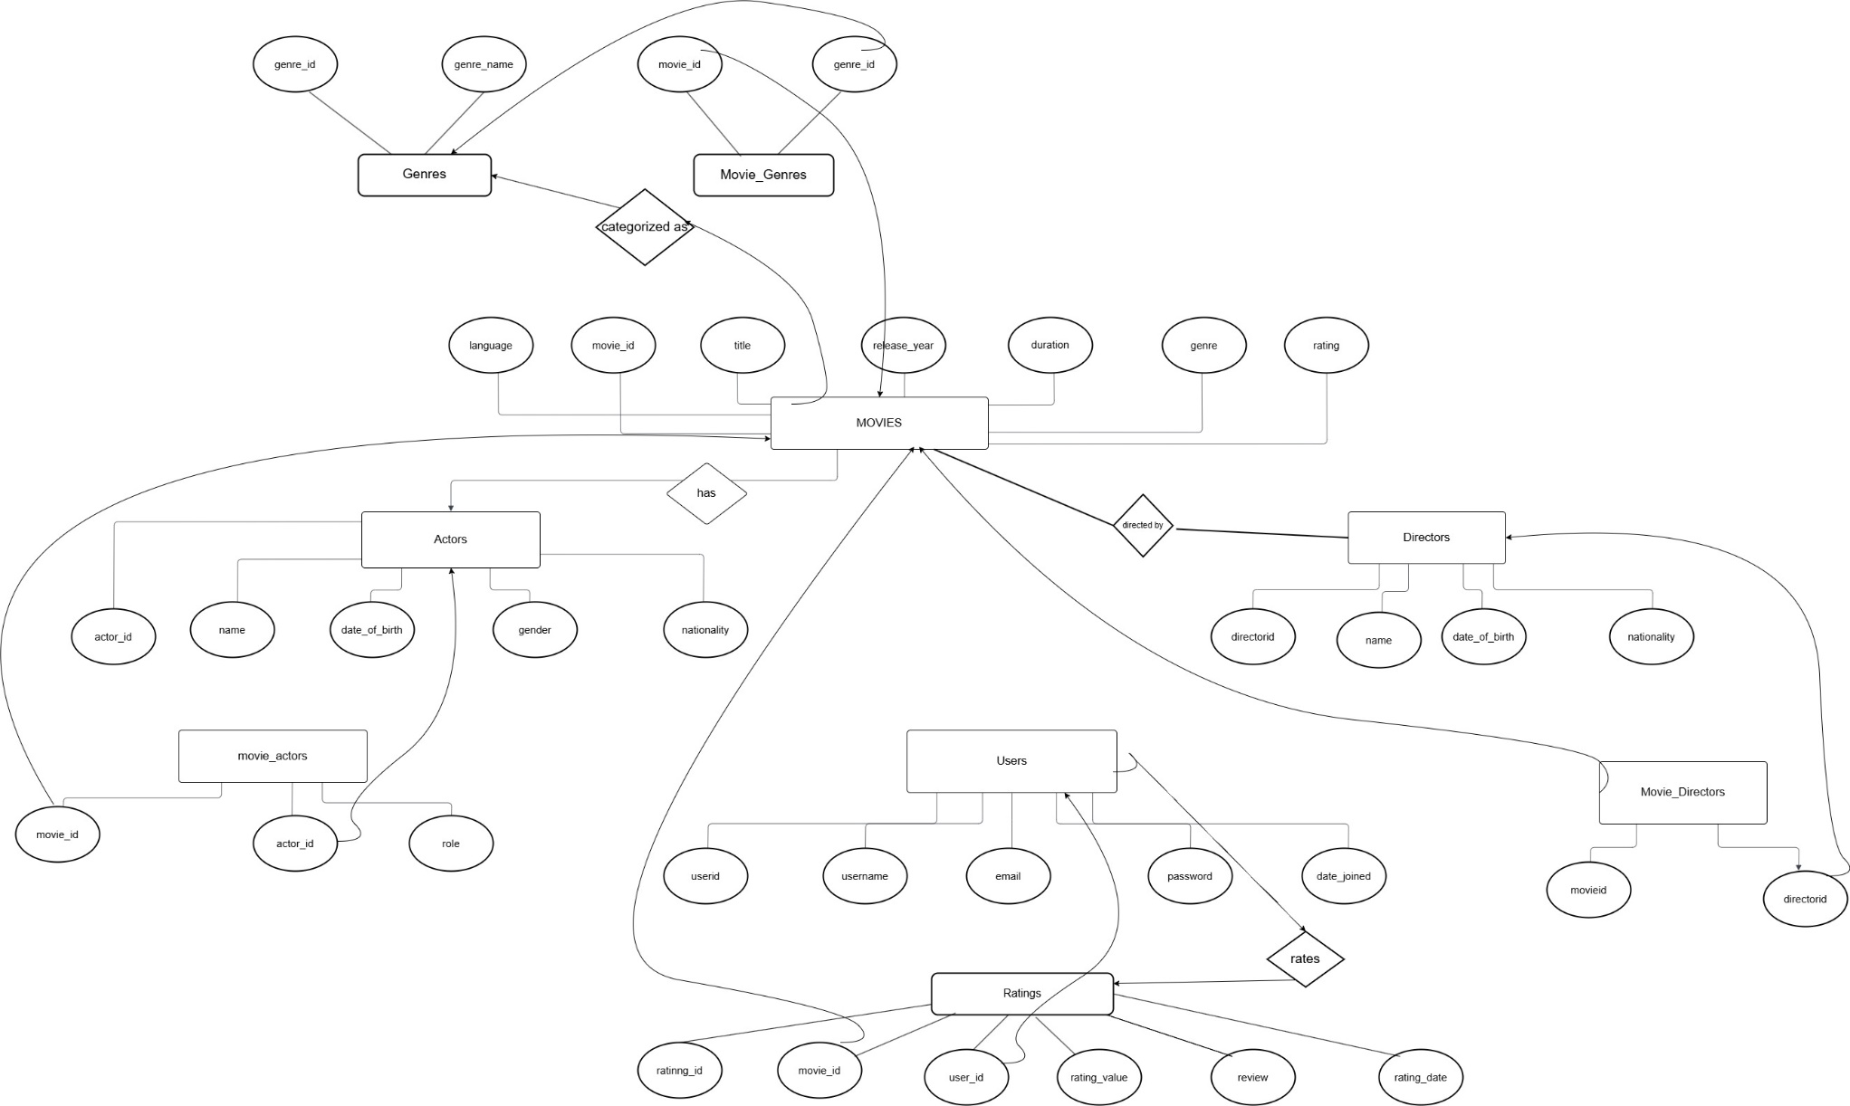

**4. Functionality**

The **Movie Database Management System** provides several functionalities for both users and administrators to interact with the system. The system’s functionalities are categorized into four key areas:

**4.1 Movie Management**

* **Add Movie:** Admins can add new movie records, including details such as title, release year, genre, and rating.
* **Update Movie:** Admins can update movie information such as rating, language, or genre.
* **Delete Movie:** Admins can remove movies from the database.
* **View Movie Information:** Users can explore detailed information about movies, including cast, directors, genre, and ratings.

**4.2 Actor and Director Management**

* **Add Actor/Director:** Admins can add new actor or director records with relevant details.
* **Update Actor/Director:** Admins can update information about an actor or director, such as name or date of birth.
* **Delete Actor/Director:** Admins can remove actor or director records.
* **View Actor/Director Details:** Users can view the details of an actor or director, including their associated movies.

**4.3 User Registration and Ratings**

* **User Registration:** New users can register by providing a username, email, and password.
* **Rate a Movie:** Registered users can rate movies on a scale and provide written reviews.
* **Update Rating:** Users can update their ratings and reviews for movies they have previously rated.
* **View User Ratings:** Both users and admins can view the ratings and reviews left by other users.

**4.4 Genre Management**

* **Add Genre:** Admins can add new genres to the system.
* **Update Genre:** Admins can modify the name or details of an existing genre.
* **Assign Genre to Movie:** Admins can link movies to one or more genres, categorizing the movies for easier exploration.

**5.WORKING FLOW**

**1.HOME PAGE(*SHOWS HIGHEST RATED MOVIES IN DATABASE)***

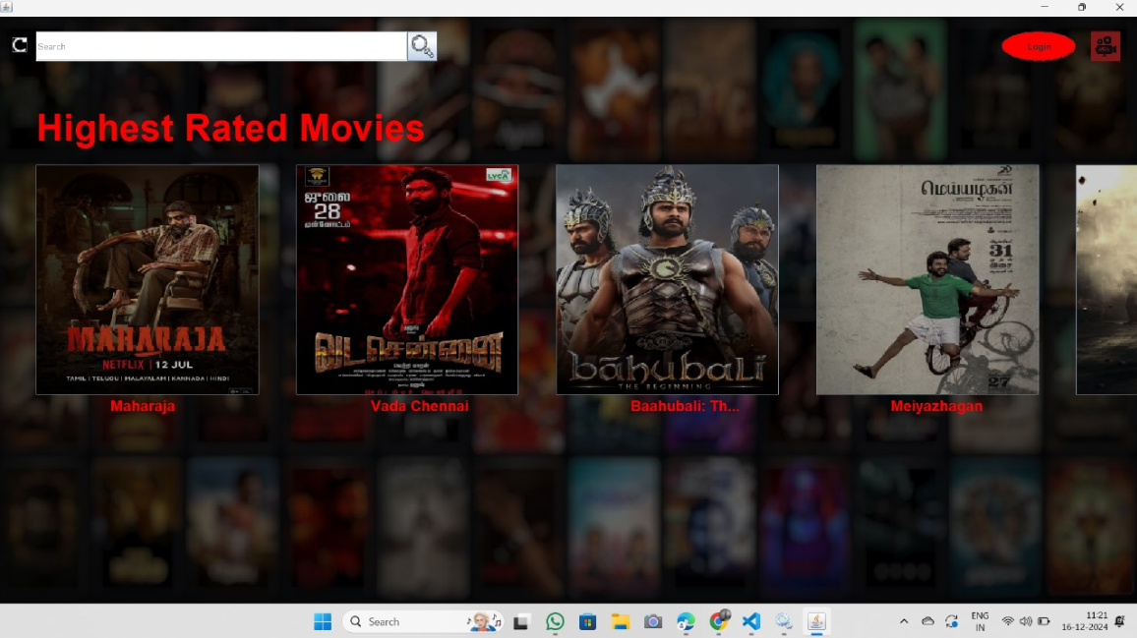

**2.USER LOGIN / NEW USER SIGN UP PAGE**

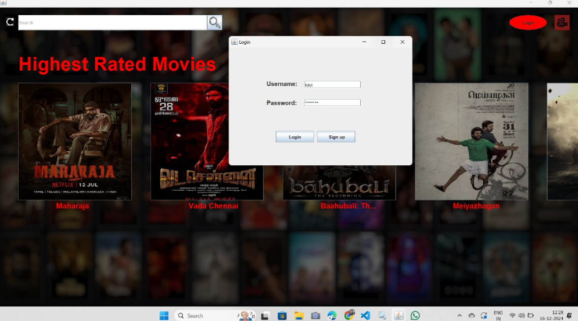

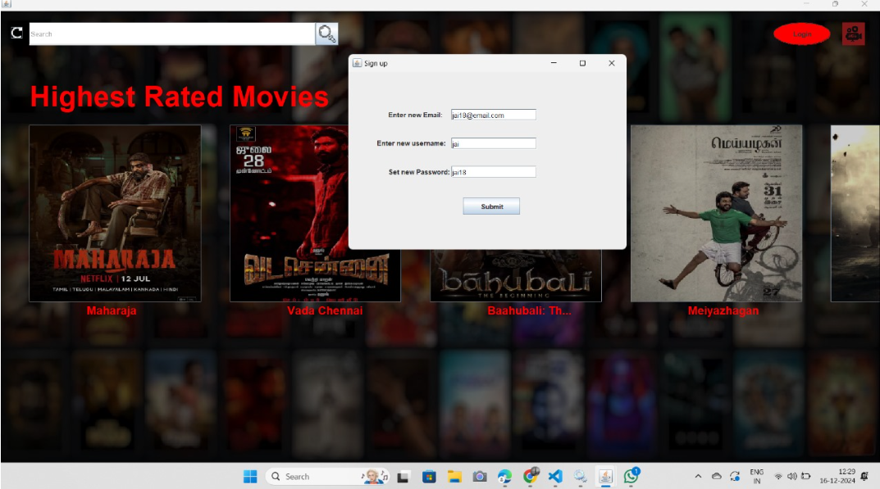

**3.USER LOGIN SUCCESSFULL**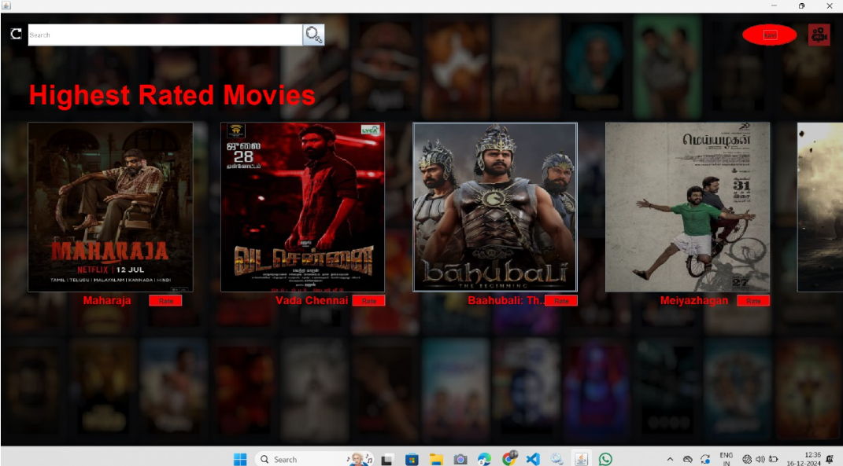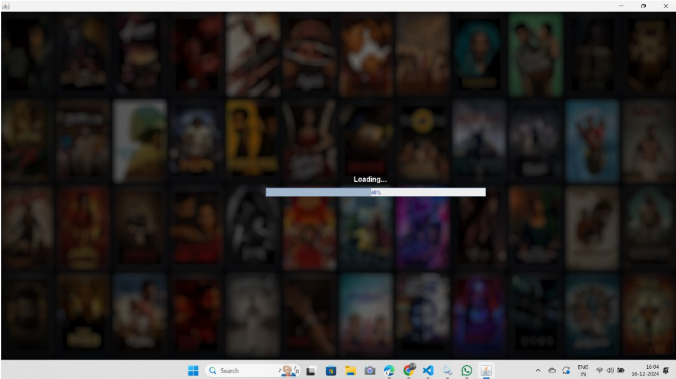

**4.MOVIE SEARCH(*ARUVI*)**

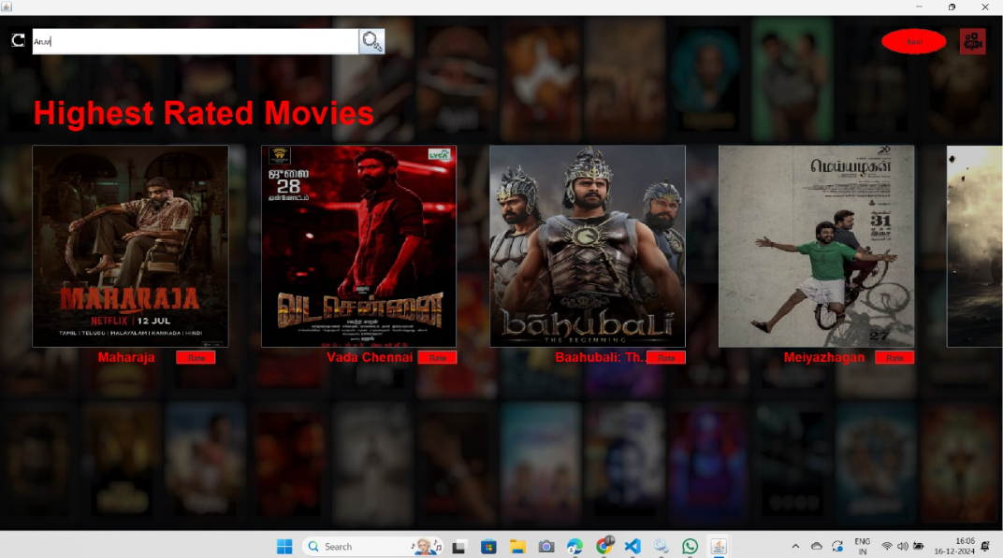

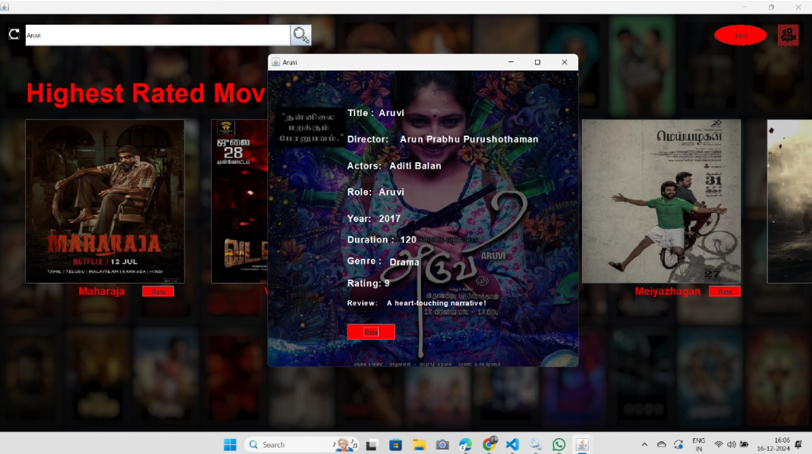

**5.USE RATE BUTTON TO RATE THE MOVIE**

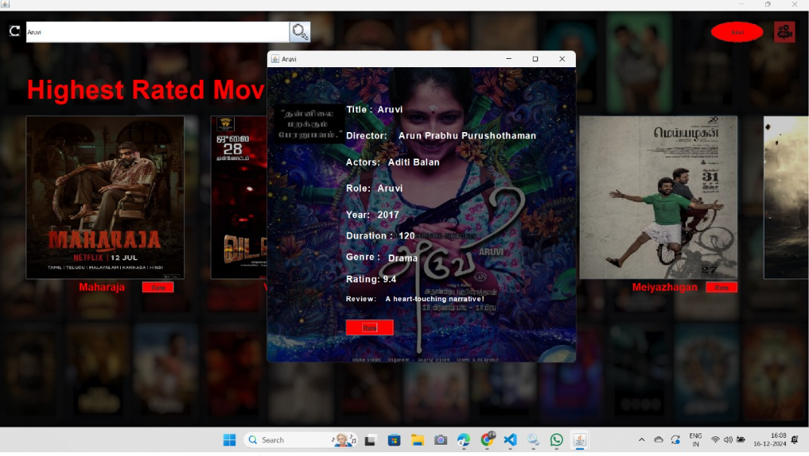

**RATING UPDATED FROM 9 TO 9.4**

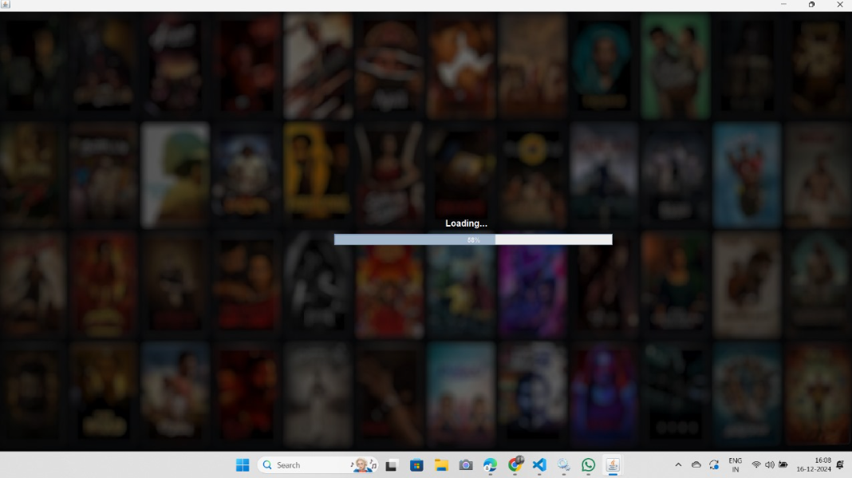

**5.ARUVI BECOMES ONE OF HIGHEST RATED MOVIES(*ADDED TO HOMEPAGE*)**

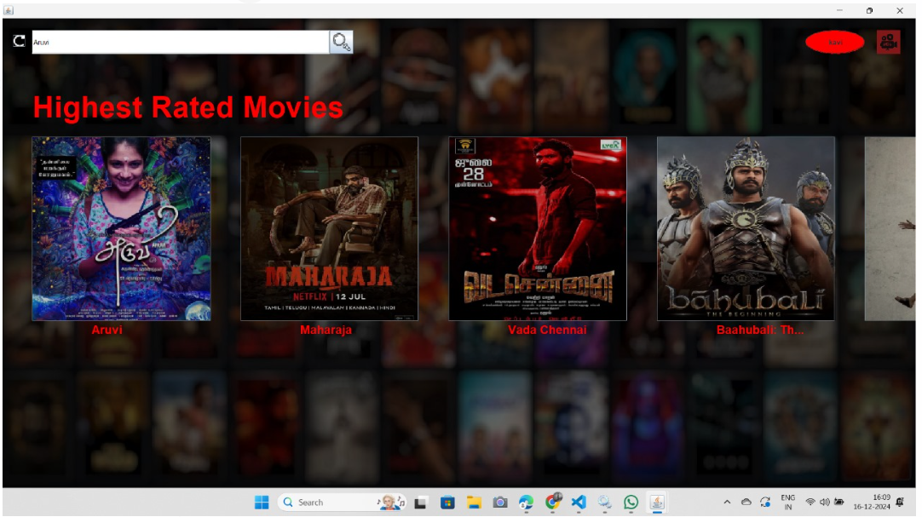

**6. Technologies Used**

* **Frontend:** Java
  + Java is used to create the user interface (UI), which allows both users and administrators to interact with the database seamlessly.
* **Backend:** Oracle Database
  + Oracle Database serves as the backend to store all movie-related data. SQL is used for database queries to insert, update, delete, and retrieve records.
* **Database Connectivity:** JDBC (Java Database Connectivity)
  + JDBC is used for establishing a connection between the Java frontend and Oracle Database, enabling smooth data retrieval and updates.

**7. Conclusion**

The Movie Database Management System (MDMS) is an efficient, comprehensive solution to manage and explore movie-related data. With features like movie management, actor and director management, user registration, ratings, and genre categorization, the system offers an organized and user-friendly platform for both administrators and users. The integration of Java for the frontend and Oracle Database for the backend ensures a robust, scalable, and reliable application.

This report provides a detailed overview of the design, schema, functionalities, and technologies involved in the Movie Database Management System project. The system’s functionalities and design ensure that it can efficiently manage and present data related to movies, actors, directors, and ratings, offering a seamless experience for all users involved.